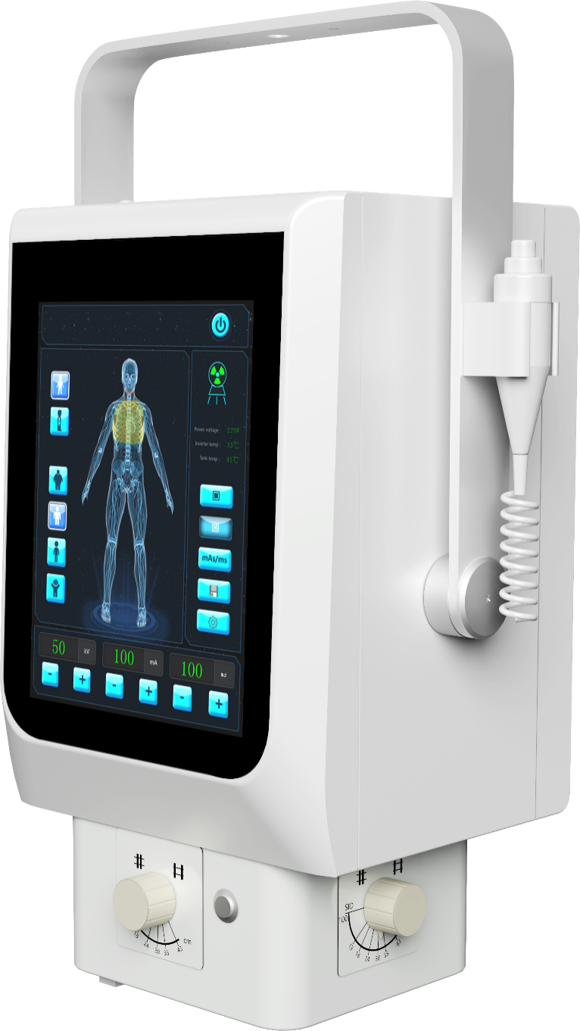

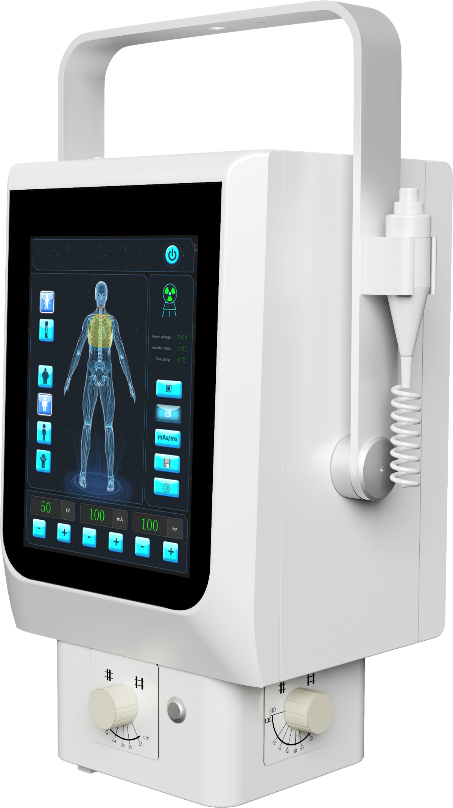
Hospitals 丨 Medical clinics 丨Nursing homes 丨Military
APPLICABLE TO

Portable X-ray Machine
Shot Lumbar Spine Master
Model: PO8R
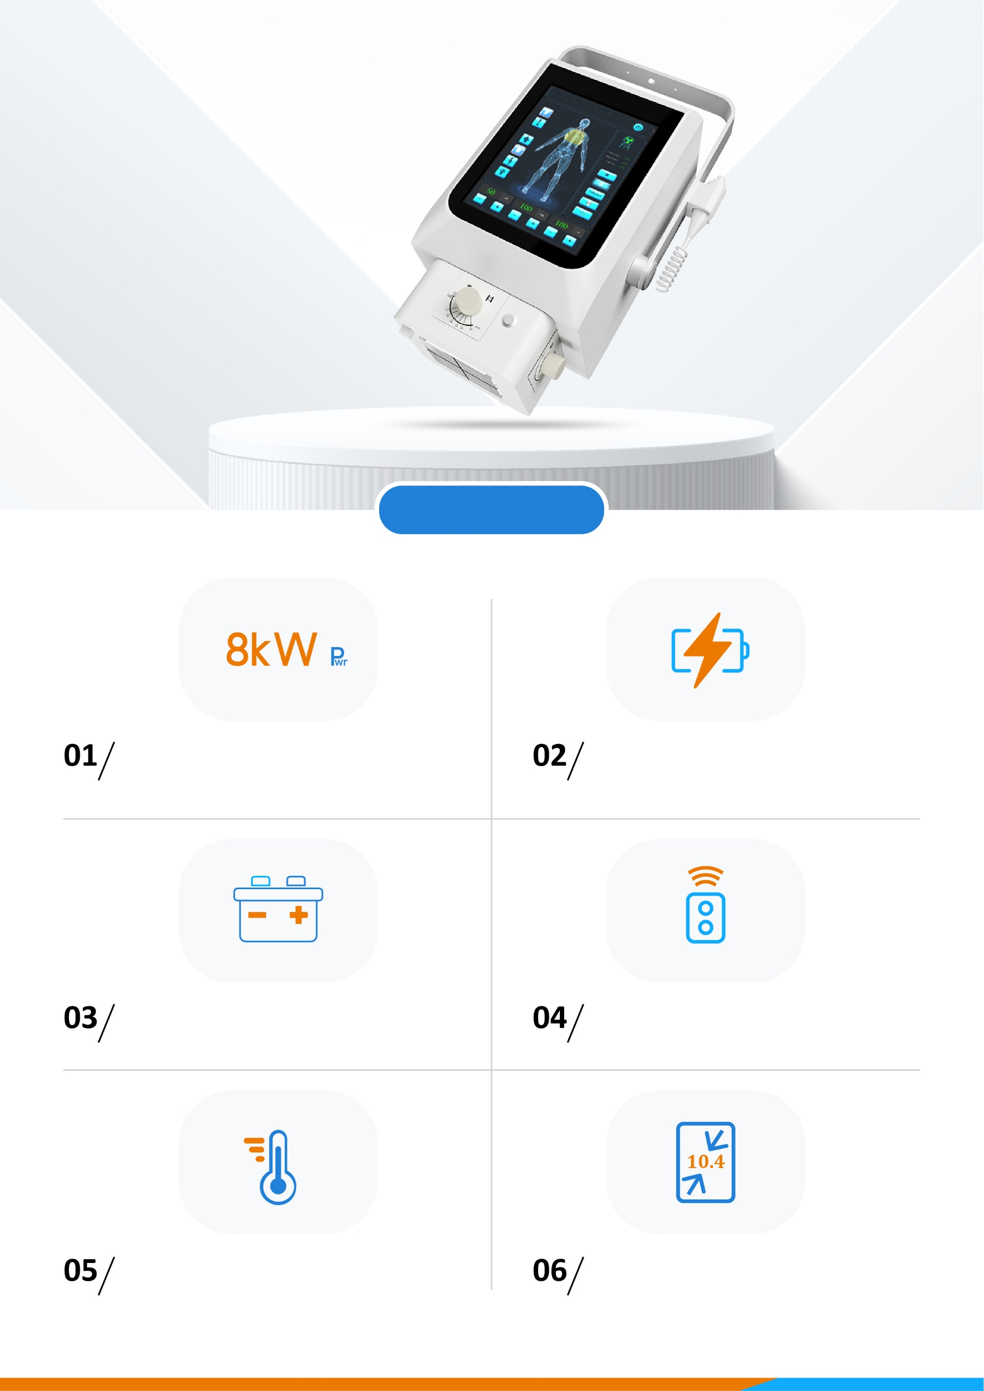
Product features
Intelligent temperature management
10.4 inch Super large screen
3 exposure modes, easy to switching
High voltage tank build inside as monoblock
Excellent exposure time
8kW High power portable X-ray machine
Ultra-portable, intuitive operation, exceptional imaging.
Clinical pictures
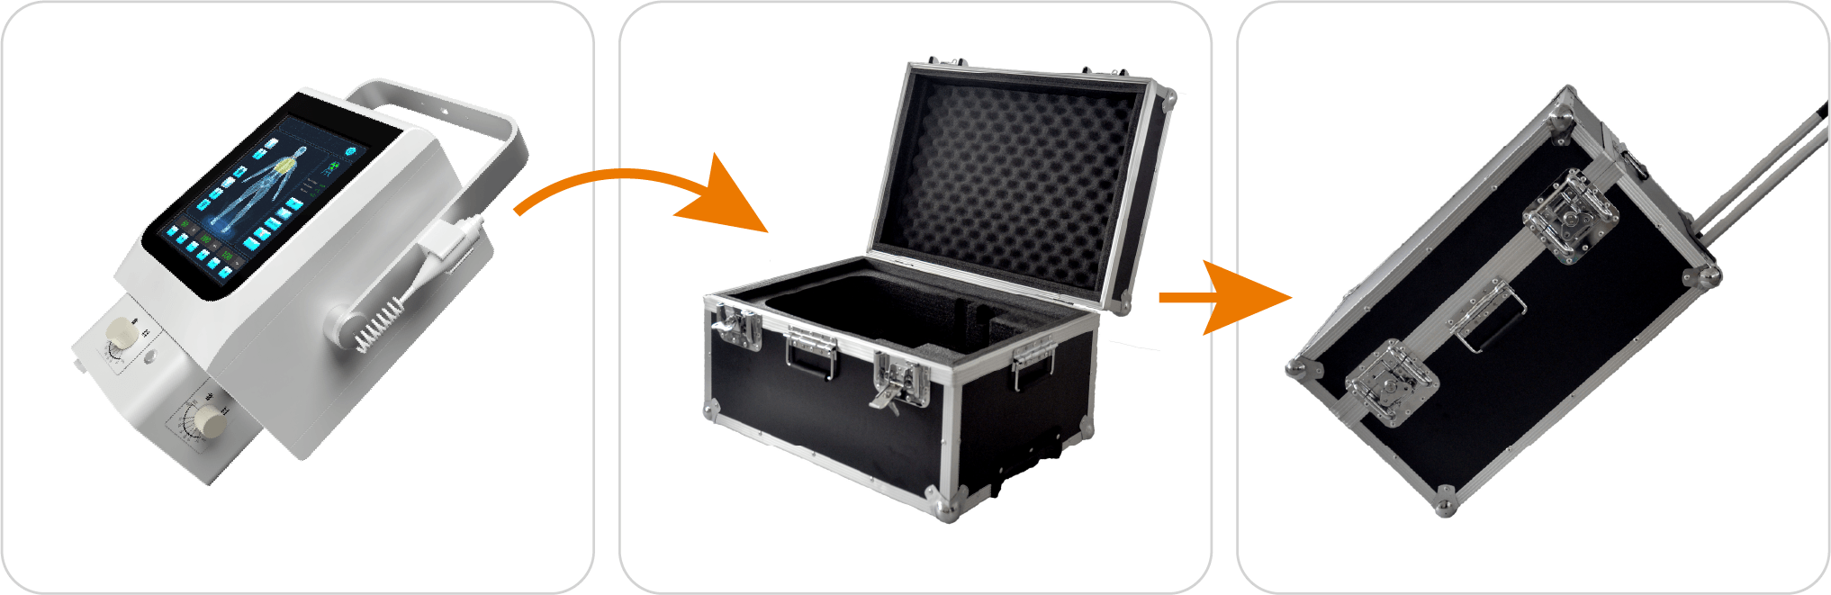
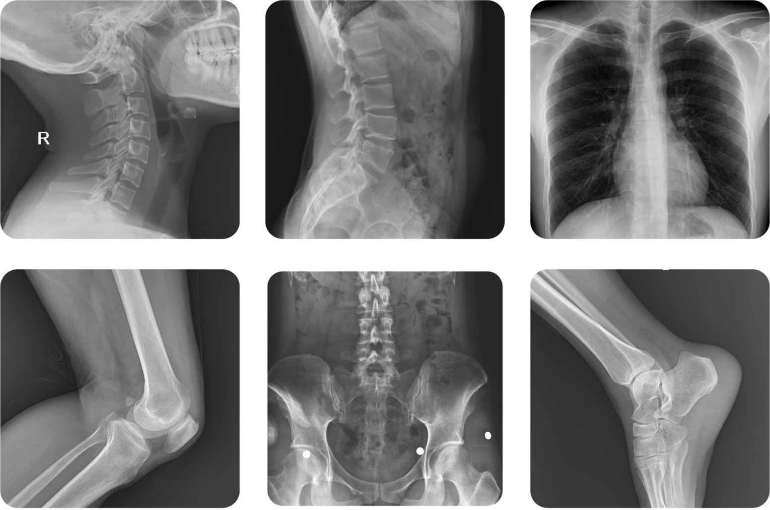

Fast and convenient packaging,Simple transportation.
Package
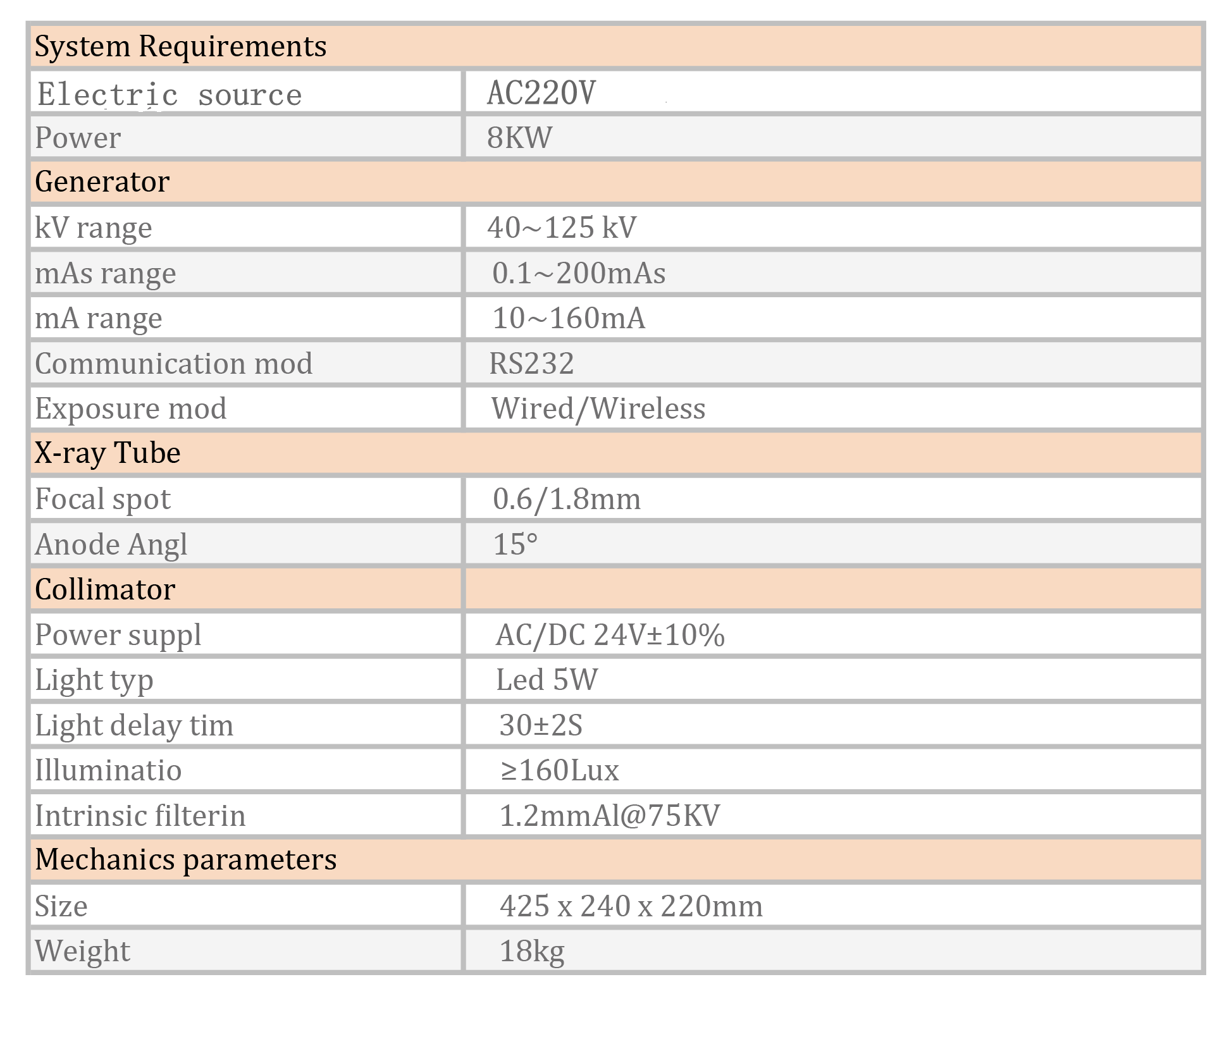

Specifications
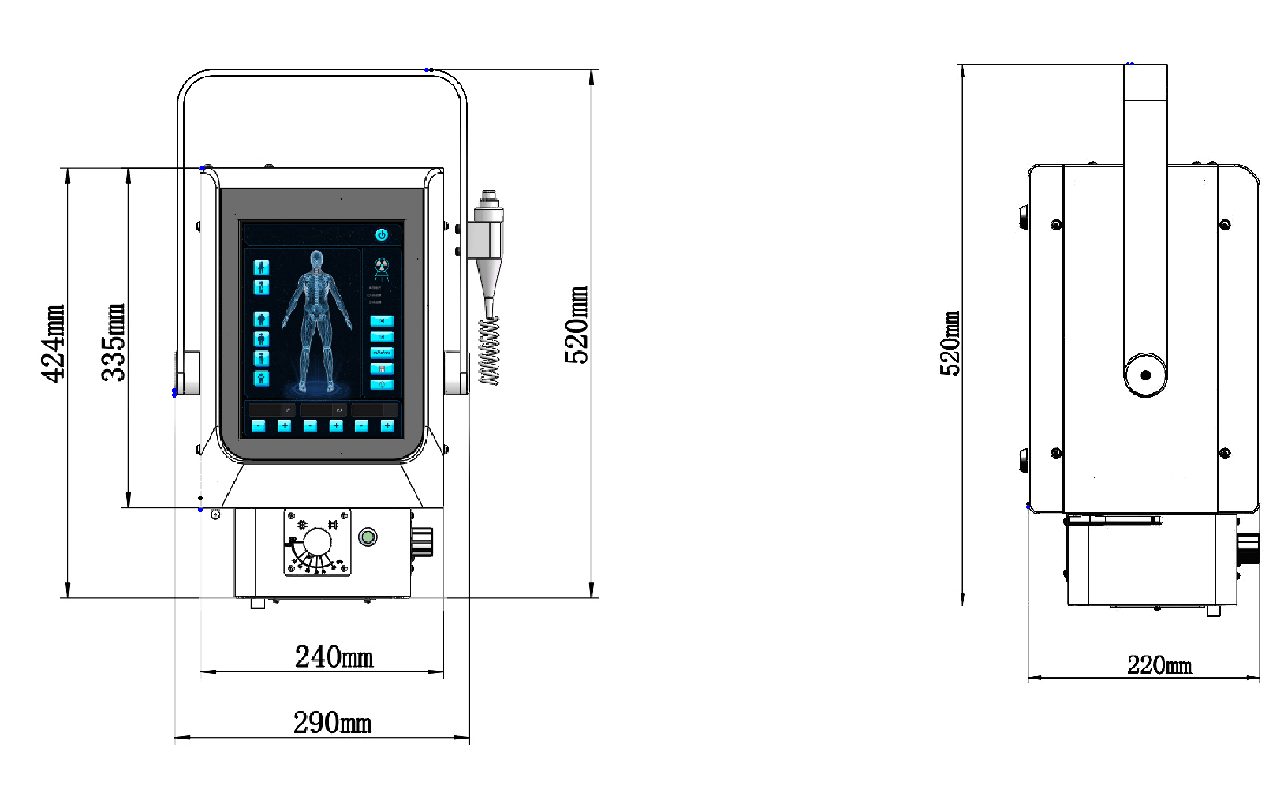
Dimension

